import pandas as pd

from sklearn.impute import SimpleImputer

from sklearn.model_selection import train_test_split

from sklearn.preprocessing import StandardScaler

from tensorflow.keras.models import Sequential

from tensorflow.keras.layers import Dense, Conv1D, Flatten

import ipywidgets as widgets

from IPython.display import display

# Read input data from Excel file

df = pd.read_excel("UCS.xlsx")  # Update with your Excel file path

# Separate input features (X) and target variable (y)

X = df.drop(columns=["UCS"])

y = df["UCS"]

# Split data into training and testing sets

X_train, X_test, y_train, y_test = train_test_split(X, y, test_size=0.2, random_state=42)

# Impute missing values in input features with the mean

imputer = SimpleImputer(strategy='mean')

imputer.fit(X_train)  # Fit the imputer on the training data

X_train_imputed = imputer.transform(X_train)

X_test_imputed = imputer.transform(X_test)

# Standardize features by removing the mean and scaling to unit variance

scaler = StandardScaler()

scaler.fit(X_train_imputed)

X_train_scaled = scaler.transform(X_train_imputed)

X_test_scaled = scaler.transform(X_test_imputed)

# Define CNN model

model = Sequential([

    Conv1D(filters=64, kernel_size=3, activation='relu', input_shape=(X_train_scaled.shape[1], 1)),

    Flatten(),

    Dense(64, activation='relu'),

    Dense(1)

])

# Compile the model

model.compile(optimizer='adam', loss='mean_squared_error')

# Train the CNN model

model.fit(X_train_scaled.reshape(X_train_scaled.shape[0], X_train_scaled.shape[1], 1), y_train, epochs=50, batch_size=32, verbose=0)

# Define input widgets for each parameter

input_widgets = {}

for i, column in enumerate(X.columns):

    min_value = df[column].min()

    max_value = df[column].max()

    input_widgets[column] = widgets.FloatText(value=float(df[column][0]), description=f"<b>{column}</b> ({min_value}-{max_value})", style={'description_width': 'initial', 'color': 'red'})

# Label to display result

result_label = widgets.HTML(value="")

# Function to predict UCS using the CNN model

def predict_ucs(btn):

    # Extract input values from the widgets

    inputs = [widget.value for widget in input_widgets.values()]

    # Transform input data using the fitted imputer and scaler

    inputs_imputed = imputer.transform([inputs])

    inputs_scaled = scaler.transform(inputs_imputed)

    # Perform prediction using the CNN model

    prediction = model.predict(inputs_scaled.reshape(1, -1, 1))[0][0]

    # Display the predicted UCS

    result_label.value = f"<b>Predicted UCS:</b> <span style='color:blue'>{prediction:.2f}</span>"

# Create a Predict button

predict_button = widgets.Button(description="Predict", button_style='primary', style={'button_color': 'blue'})

predict_button.on_click(predict_ucs)

# Attach event listener to each input widget

for widget in input_widgets.values():

    widget.observe(predict_ucs, names='value')

# Create a box for input parameters

input_parameters_box = widgets.VBox([

    widgets.HTML("<h2 style='color:red;'>Input</h2>"),

    *list(input_widgets.values()),

    widgets.HTML("<br>"),

    predict_button

])

# Create a box for output parameter

output_box = widgets.VBox([

    widgets.HTML("<h2 style='color:blue;'>Output</h2>"),

    result_label

])

# Arrange input and output boxes horizontally

input_output_box = widgets.HBox([input_parameters_box, output_box])

# Style the input and output boxes

input_parameters_box.layout.margin = '20px'

input_parameters_box.layout.padding = '20px'

output_box.layout.margin = '20px'

output_box.layout.padding = '20px'

input_output_box.layout.border = '2px solid #ccc'

input_output_box.layout.border_radius = '10px'

input_output_box.layout.margin = '50px auto'

input_output_box.layout.width = '60%'

input_output_box.layout.box_shadow = '5px 5px 5px #888888'

# Display the GUI

display(widgets.VBox([

    widgets.HTML("<h1 style='text-align:center;'> UCS Prediction using CNN</h1>"),

    input_output_box

]))

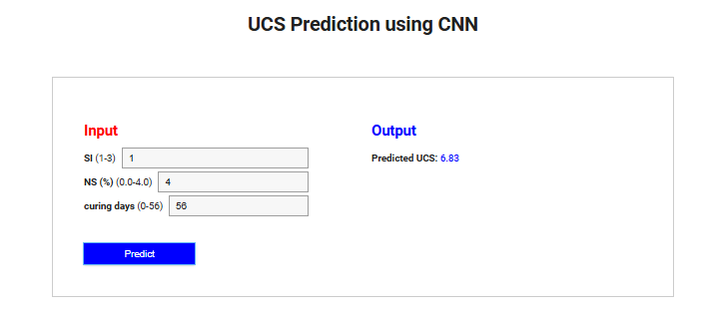

**GUI for prediction of UCS for NS fine-grained soil**